

**Faculty of engineering - Shoubra**

**Benha University**

**Research Project**

in fulfillment of the requirements of

|  |  |
| --- | --- |
| **Department** | **Engineering Mathematics and Physics** |
| **Division** | **--------** |
| **Academic Year** | **2019-2020 Preparatory** |
| **Course name** | **Computer** |
| **Course code** | **ECE001** |

**Title: -**

**Build a website on Artificial Intelligence**

By:

|  |  |  |  |
| --- | --- | --- | --- |
|  | Name | Edu mail | B.N |
| 1 | سمر محمود أحمد حامد | samar195444@feng.bu.edu.eg | 397 |

**Approved by:**

|  |  |
| --- | --- |
| Examiners committee | Signature |
| Dr.Ahmed Bayoumi |  |
| Dr.Shady Elmashad |  |
| Dr. Abdel Hamid Attaby |  |

**Table of contents**

|  |  |
| --- | --- |
| **Subject / section** | **Page** |
| Introduction to AI | 2 |
| Screenshots | 3 |
| Source code | 5 |
| References | 7 |

* **GitHub Page URL:** <https://samar-mahmoud.github.io/ECE001/>
* **GitHub Repository Link:** <https://github.com/Samar-Mahmoud/ECE001>
* ***Introduction to AI***

Artificial intelligence is based on the principle that human intelligence can be defined in a way that a machine can easily mimic it and execute tasks, from the most simple to those that are even more complex.

Artificial intelligence (AI) is the simulation of human intelligence processes by machines, especially computer systems. Specific applications of AI include expert system, natural language processing (NLP), speech recognition and machine vision. The ability of a digital computer or computer-controlled robot to perform tasks commonly associated with intelligent beings. The term is frequently applied to the project of developing systems endowed with the intellectual processes characteristic of humans, such as the ability to reason, discover meaning, generalize, or learn from past experience.

General programming languages such as C++ and Java are often used because these are the languages with which most computer scientists have experience. There also exist two programming languages that have features that make them particularly useful for programming Artificial Intelligence projects PROLOG and LISP.

AI can be categorized as either weak or strong. Artificial Intelligence can be categorized into four types, beginning with the task-specific intelligent systems in wide use today and progressing to sentient systems, which do not yet exist. These types are: Reactive machines, Limited memory, Theory of mind and Self-awareness.

Artificial intelligence has advantages and disadvantages. There are several examples of AI technology such as Automation, Machine vision, Robotics and Self-driving cars. AI is also used in different applications such as healthcare, education, business and transportation.

* **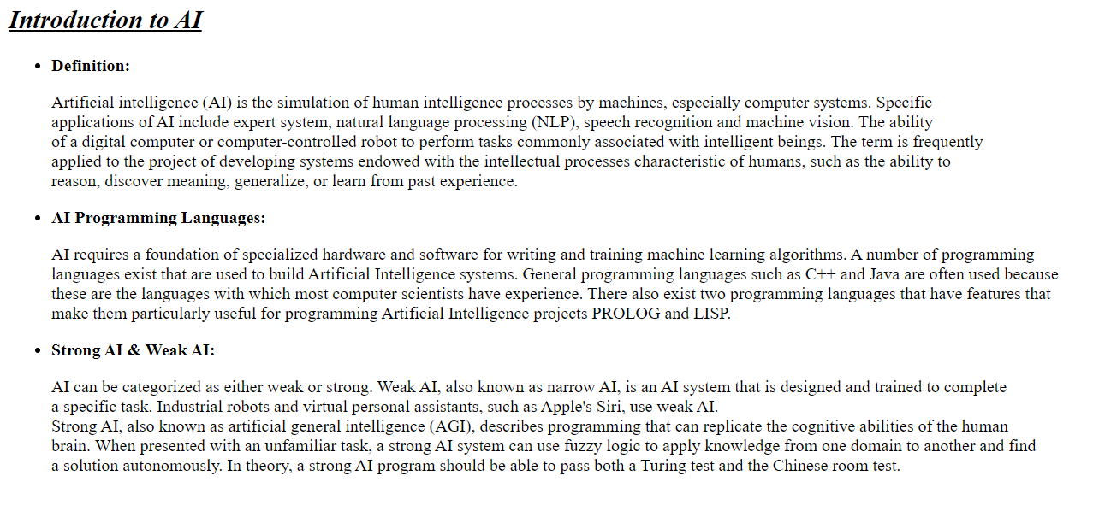 *Screenshots***

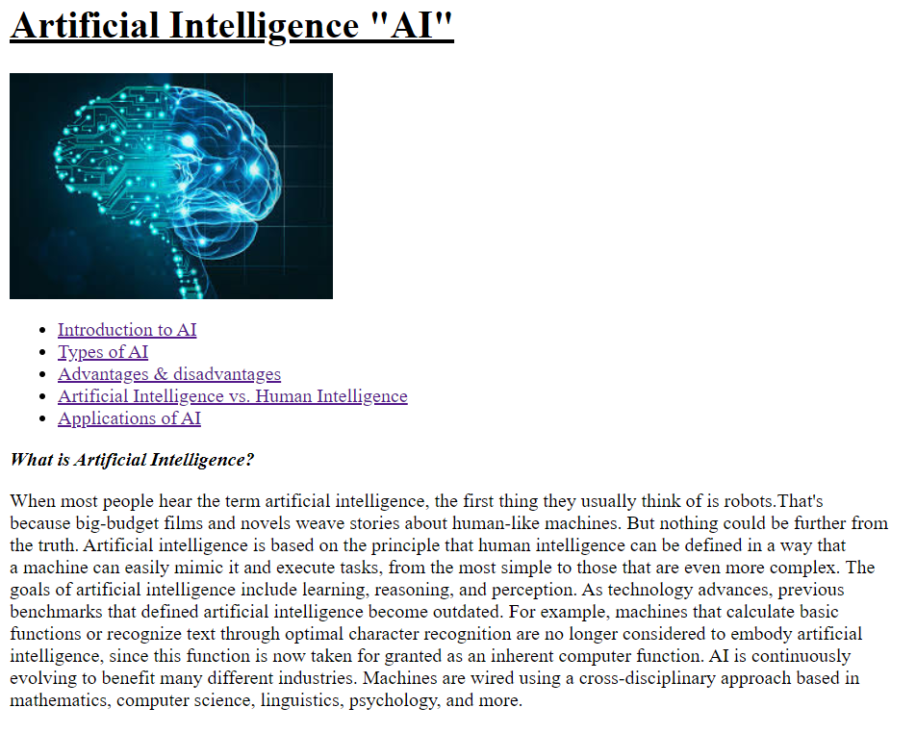

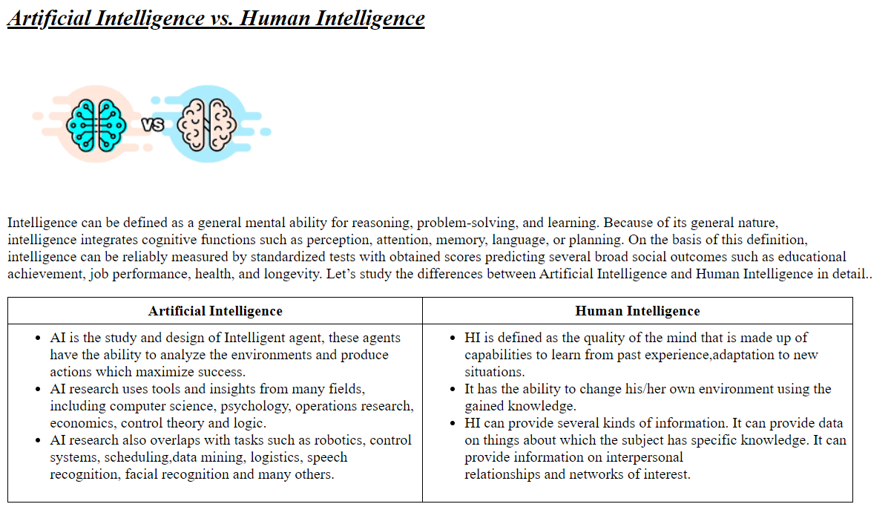

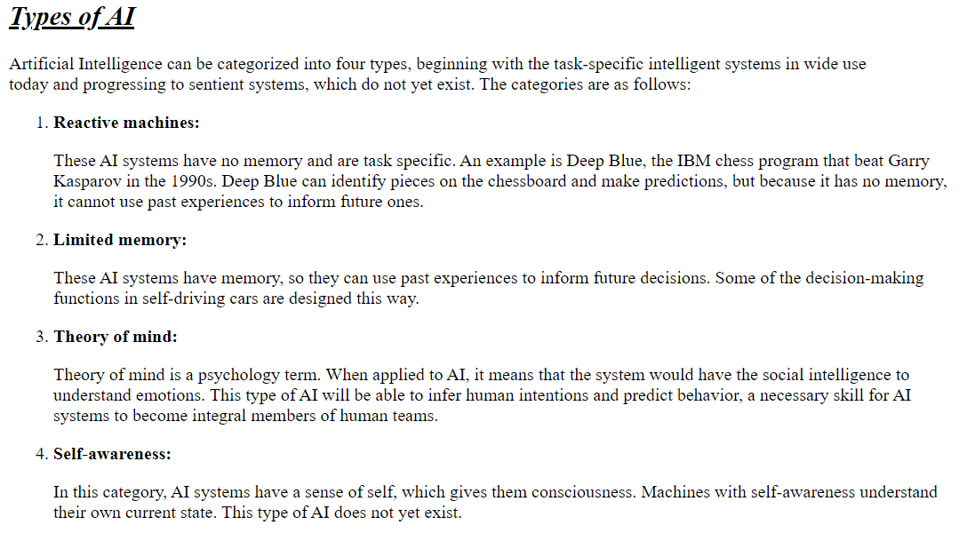

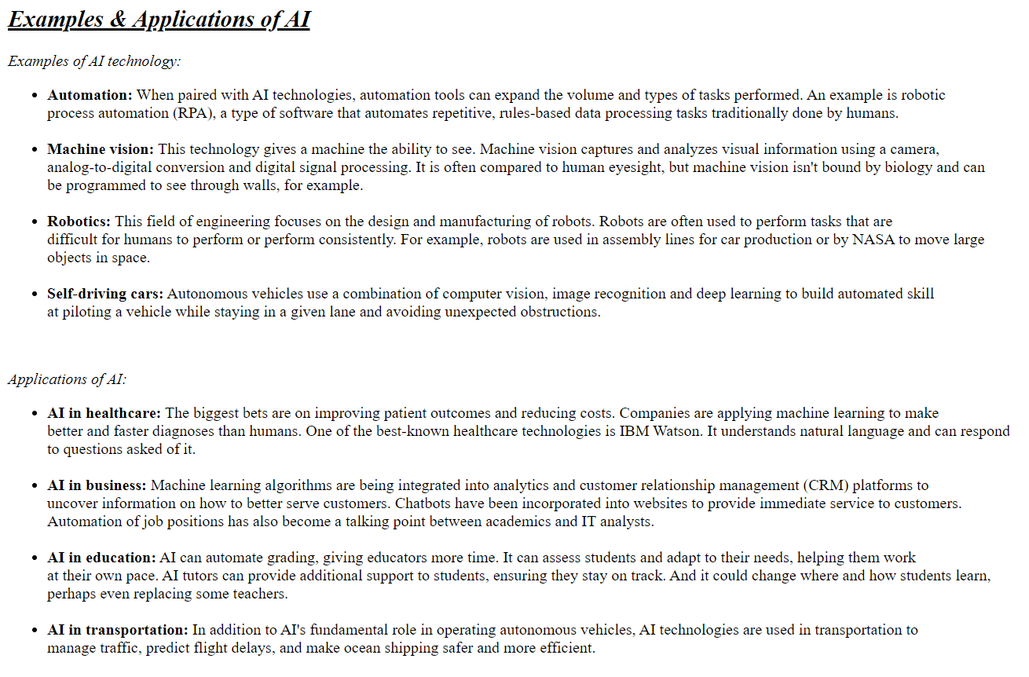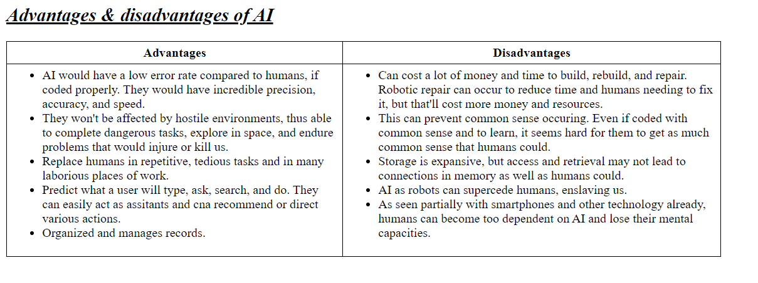

* 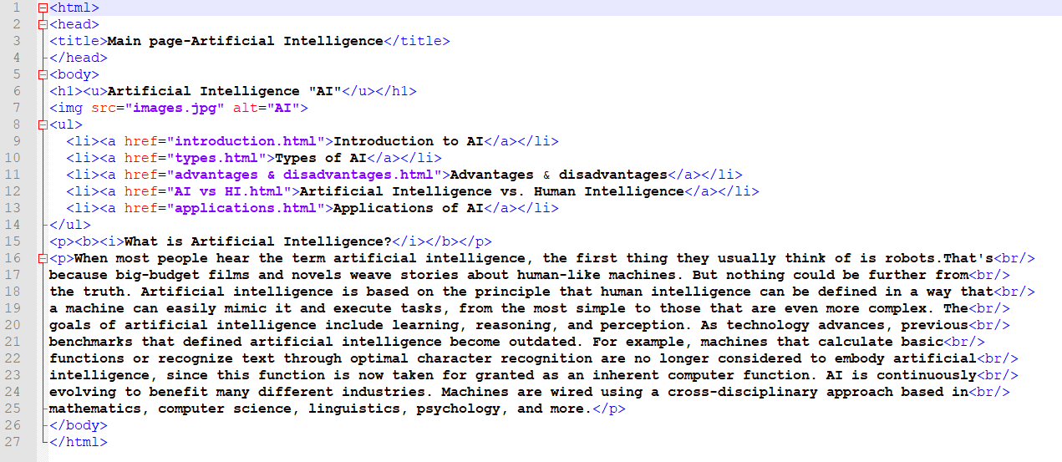 ***Website source code***

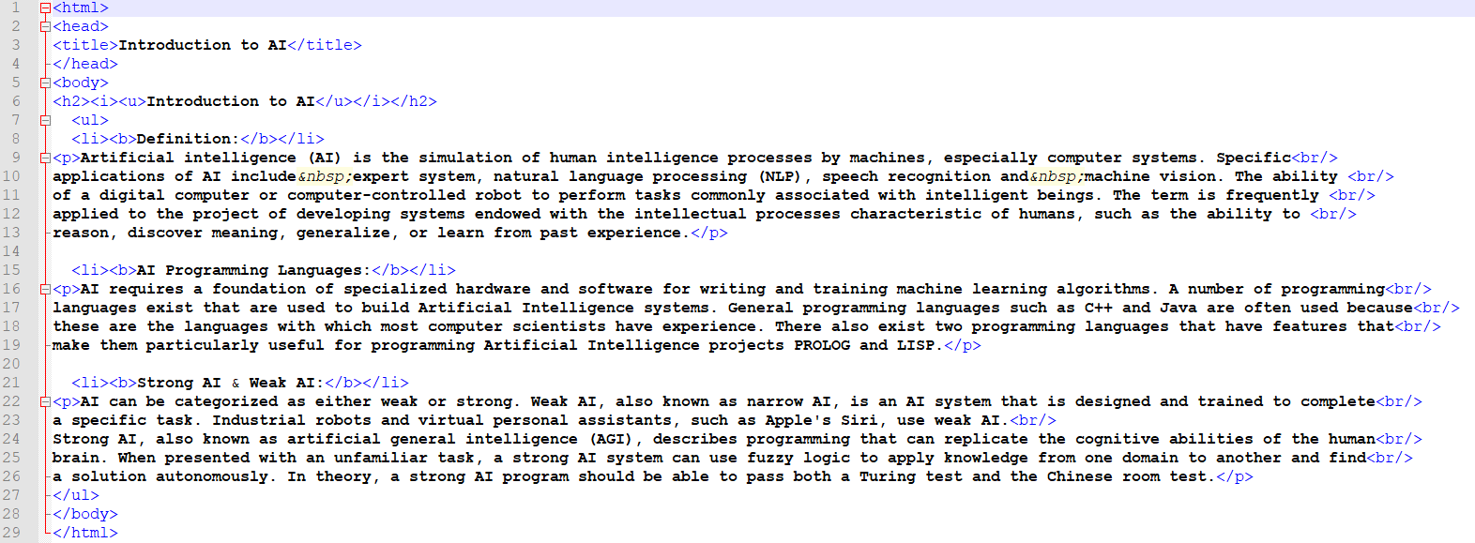

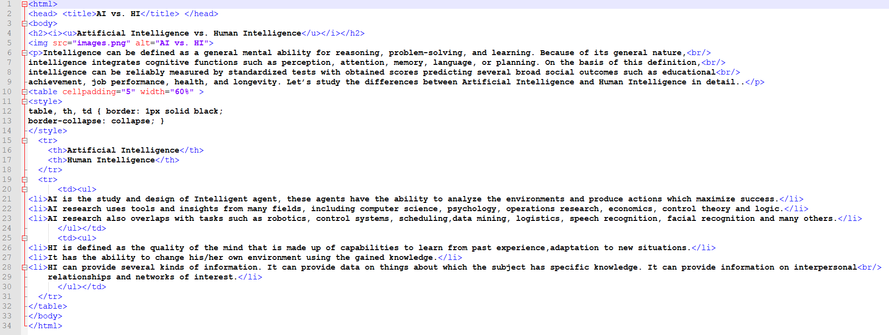

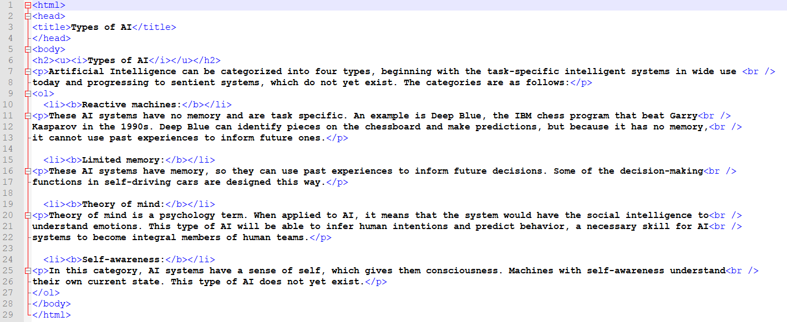

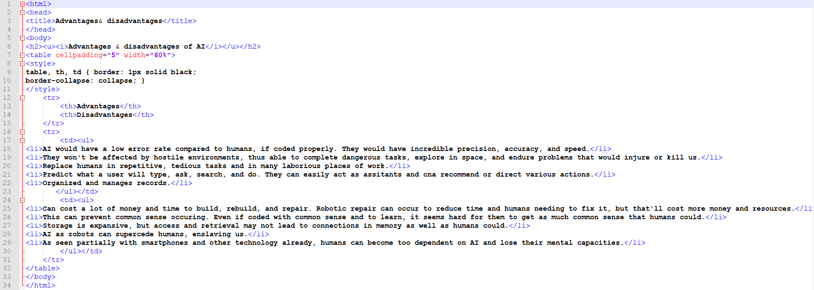

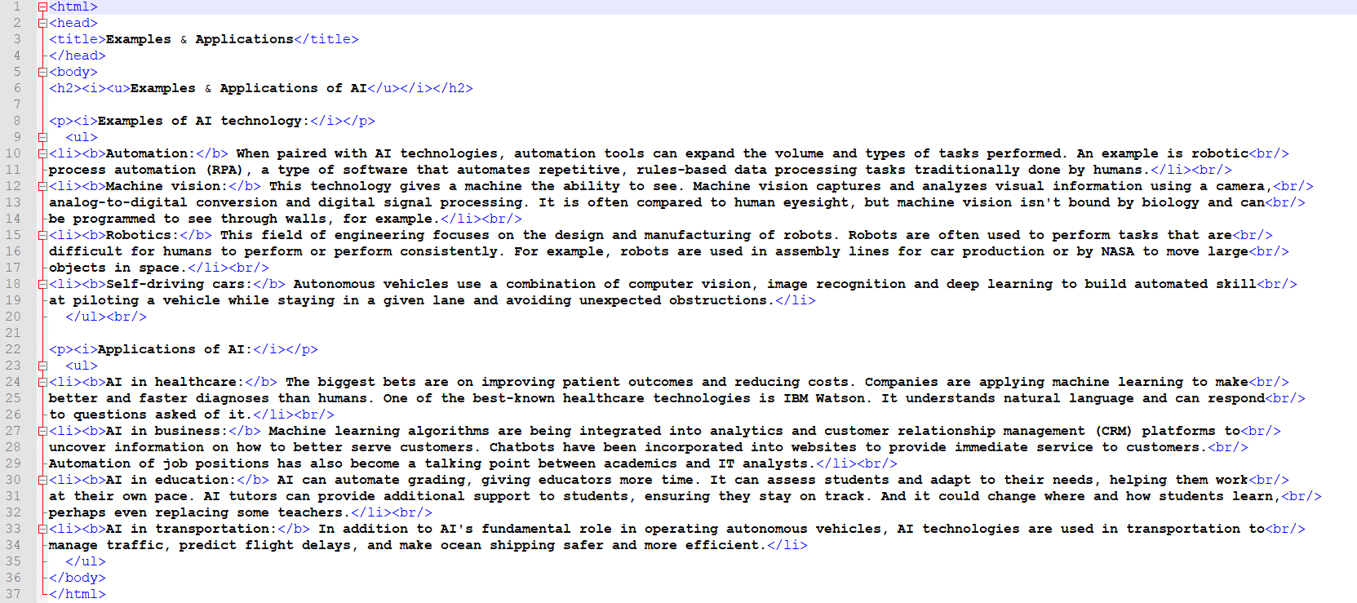

**References**

- Artificial Intelligence Illuminated, by Ben Coppin, Jones and Bartlett publishers. <https://www.pdfdrive.com/artificial-intelligence-illuminated-e1083124.html>

- Artificial Intelligence for Big Data: Complete guide to automating Big Data solutions using Artificial Intelligence techniques, by Anand Deshpande & Manish Kumar. <https://www.pdfdrive.com/artificial-intelligence-for-big-data-complete-guide-to-automating-big-data-solutions-using-artificial-intelligence-techniques-e176460425.html>

- TechTarget, AI-Artificial-Intelligence. <https://searchenterpriseai.techtarget.com/definition/AI-Artificial-Intelligence>